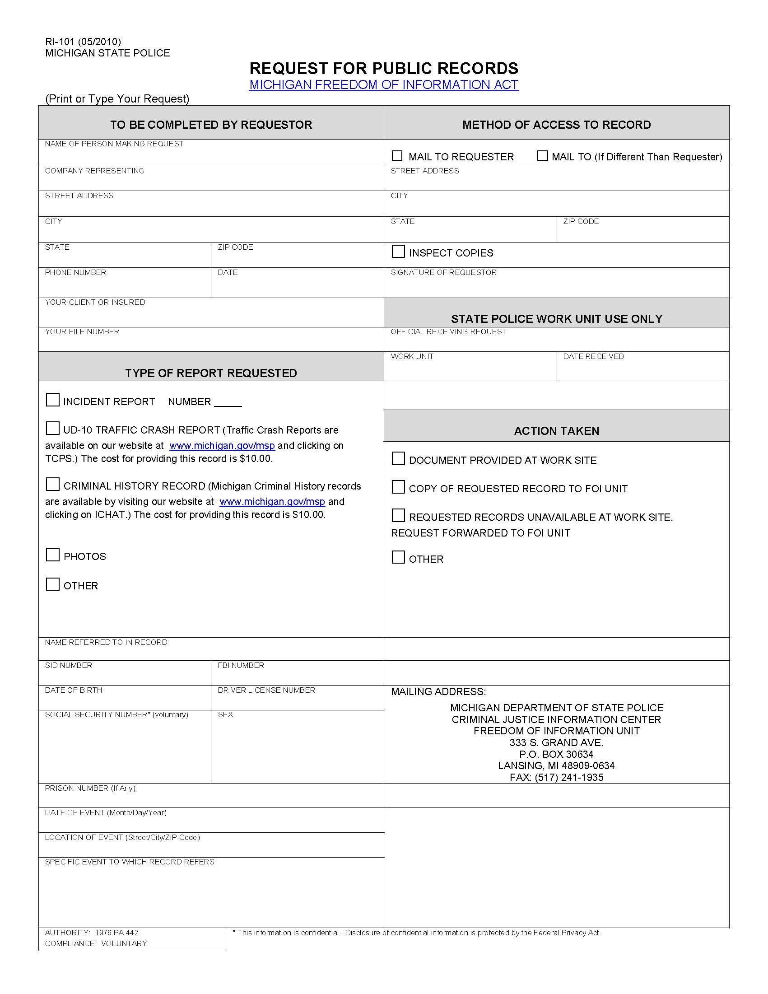

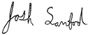
`
Order No. 01-36113 - 001
George Carey

MI
Axiom Requisition Copy Service, as agent of David Pizzica

xxx-xx-1613
2869 Jolly Road

Okemos

(877) 886-5090

05/21/1949

48864
X

FROM 05/21/1949 TO PRESENT: Any and all MEDICAL RECORDS, including but not limited to patient history form(s), reports, etc. pertaining to George Carey SSN: xxx-xx-1613, DOB: 05/21/1949.
David Pizzica, Lucas and Cavalier, LCC
01-36113 - 001
X
X

